**SkyCroft Conference Center Summer Camp**

COSC-578 GROUP PROJECT

Group Members:

Winsum Chang

Kaitlyn Griffin

Steven Pugh

Komal Soni

Hailey Wilson

**TABLE OF CONTENTS**

|  |  |
| --- | --- |
| Content | Page # |
| Summary | 3 |
| Business Profile | 3 |
| Problem Statement | 4 |
| Scope of the Project | 4 |
| Requirements | 4 |
| Entity Relationship Diagram | 5 |
| Schema | 6 |
| Database Queries | 7-8 |
| Meeting Log | 8 |
| Reference Manual/Tutorial | 9-13 |

**Summary**

The aim for this project is to develop a database application for the Skycroft Conference Center; a Christian organization that hosts church retreats throughout the summer. The development for this project began in early February 2019. The database that is being designed for this organization will be used to help record and keep track of all of the participating students in various circuits (activities) that will take place throughout the summer. When students go to register, they are provided a list of circuits that they could attend. Students will create a list of preferences for which circuits they want and will then be randomly sorted into those circuits based off of certain criteria such as the maximum of students that can attend one circuit or if a circuit is limited to a certain grade level. The application is meant to help the organization keep track of which students are signed up for which circuits as well as prevent students from signing up for circuits they do not qualify for. The database for this project will be created in MySQL and the front-end user interface will be designed using Java Swing.

**Business Profile**

Skycroft Conference Center is located on almost 350 acres atop the beautiful South Mountain in Frederick County, Maryland. Owned and operated by the Baptist Convention of Maryland/Delaware, the center opened in 1977. Development has continued to accommodate 300+ overnight guests year round. Many people take advantage of the opportunity to slip away into a quiet spot to reflect, to be re-created, and to be refreshed in the beauty of “God’s great outdoors”. They offer a variety of housing accommodations, beautiful surrounds, excellent dining options, and warm and friendly service at reasonable rates. Both indoor and outdoor recreational opportunities are available. Skycroft and the surrounding area are rich in Civil War history, where a significant part of the Battle of South Mountain was fought in 1862. Roughly a mile and a half away stands the Washington Monument State Park which host a stone tower dedicated to Washington himself that overlooks the valley below.

**Problem Statement**

The database for this organization is being designed in order to organize the circuits (activities) in which students attend as part of their camp throughout the summer. Students can pick which circuit they want to take part in but must take into consideration certain restrictions such as maximum and minimum size of the circuit, gender, Jr/Sr in high school, etc. Students have information used to identify them (First Name, Last Name, Church Name, Gender, Grade) as well as have a limit as to how many circuits they can attend. A student can attend a maximum of three circuits and have up to four preferences to choose from.

**Requirements**

**1. Process Modelling Requirements:**

The SkyCroft Conference Center Summer Camp System is an organization system that assigns students on retreats at the conference center to various activities. The attributes for students are: studentID, FirstName, LastName, churchName, gender, grade. Each student is uniquely identified by studentID. The attributes for preferences are: prefNum, circuitNum, curcuitID, studentID. Students will have up to four preferences and each preference must belong to one or more student in the case that multiple students have the same preferences. Each preference is identified by prefNum and has a foreign key of circuitNum from Circuits and studentID from Student. Available circuits must make up a the preferences a student has and vice versa, such that preferences must come from available circuits. The attributes for circuits are: circuitID, circuitName, minSize, maxSize. Each circuit is identified by circuitID. Circuits may have only one gender requirement and/or may have only one grade requirement or even one of each. Gender requirements and grade requirements must belong to one or more circuits. The attributes for gender requirements are : gender and cicuitID. Each gender requirement is uniquely identified by gender and has a foreign key of circuitID from circuits. The attributes for grade requirement are : grade and cicuitID. Each grade requirement is uniquely identified by grade and has a foreign key of circuitID from circuits. The assignments which students must be assigned to must also come from the available circuits. A student cannot be assigned to something that is not a circuit. The attributes for assignments are : studentID, circuitNum, circuitID. Each assignments is uniquely identified by the combination of all three, two of which (studentID and circuitID) are foreign keys from their respective entities.

**2. Data Modelling Requirements:**

The application designed should be able to perform the following functions:

1. Admin user should be able to view all the information about the students
2. Admin user should be able to view all the information about all the circuits
3. Admin user should be able to view student information based off of different attributes
4. Admin user should be able to insert as many students as needed
5. Admin user should be able to delete a student(s)
6. Admin user should be able to modify information
7. Admin user should be able to view all students assigned to a circuit

**Entity Relationship Diagram**

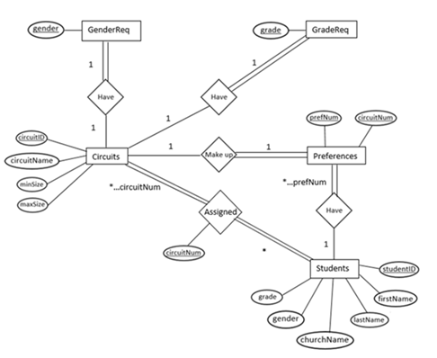

**Schema**

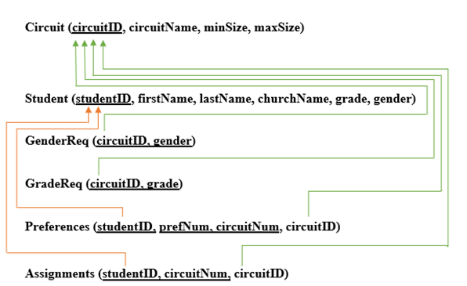

**Database Queries**

**Create Table:**

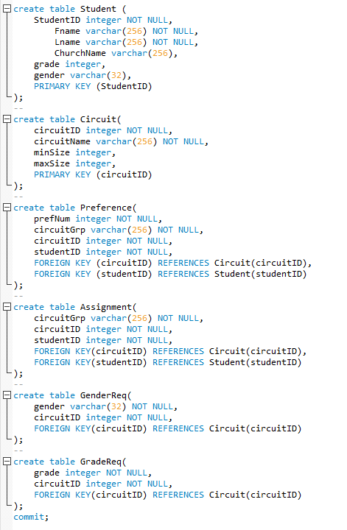

**Insert:**

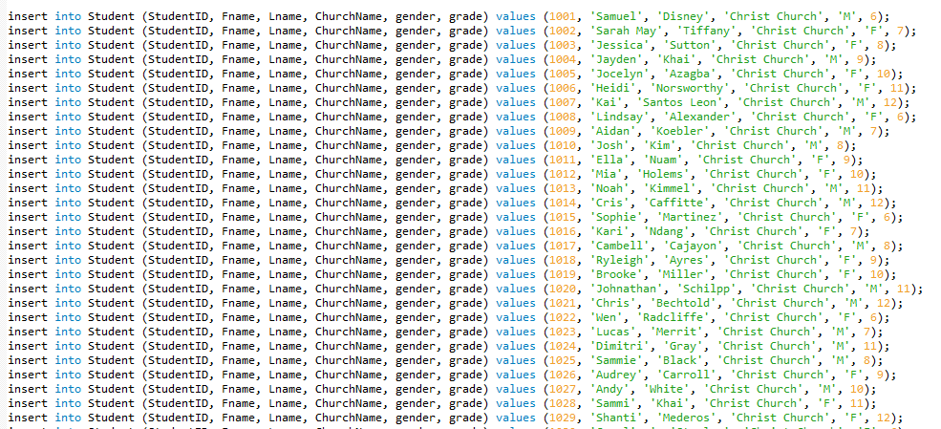

**Meeting Log**

|  |  |  |  |
| --- | --- | --- | --- |
| **Task** | **Date** | **Attendees** | **Location** |
| Choosing an Organization | 2/2-2/3 | All | Self/Conference Call |
| Requirements Gathering/Analysis | 2/9-2/10 | All | York Building |
| Research/Tutorials | 2/14-2/21 | All | Self |
| ERD Diagram | 2/23-2/24 | All | York Building |
| First Report Draft | 3/2-3/3 | All | Self |
| Finalize First Report | 3/4-3/8 | All | Self/York Building |
| Research/Back-End | 3/24-4/6 | All | Self/Conference Call |
| Research/Front-End | 4/7-4/20 | All | Self/Conference Call |
| Back-End/Front-End | 4/21-4/27 | All | Self/York Building |
| Testing/Drafting Final Report | 4/28-5/4 | All | Self/York Building |
| Presentation | 5/5-5/9 | All | Self/York Building |

**Reference Manual**

**Introduction to the SkyCroft Conference Center Summer Camp System**

Skycroft Systems will improve the daily activities for authorized admins. By being able to track student activity preferences and student activity placement, the admins can ensure that students are placed in activities which fit they fit the criteria for.

Admin users will have the capabilities to update personal information of students. They may also add and remove students from the system to ensure that everything is current and up-to-date.

User’s perspectives for all admin users will be identical and easy to navigate through (See Reference Manual).

SkyCroft Conference Center Summer Camp System goal is to provide security, enhance organization and provide a database system that is functional an easy to use.

**Target Application Use**

This system is to be used as an assignment system. It will take in all the information on each student and their activity preferences, and then place them accordingly. It will ensure students do not get placed in activities they do not fit the criteria for and will help to increase the frequency of students receiving placements that are high on their preference list.

**Application Audience**

This system is intended for admin users of the SkyCroft Conference Center Summer Camp. Admins of the SkyCroft system will use this manual to learn how to use the interface of the prospective system.

Note that students shall not be allowed access to this system for any use or purpose.

**User Login:**

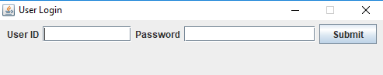

**Home Page:**

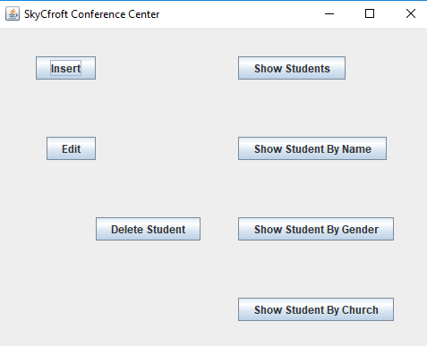

**Insert Student:**

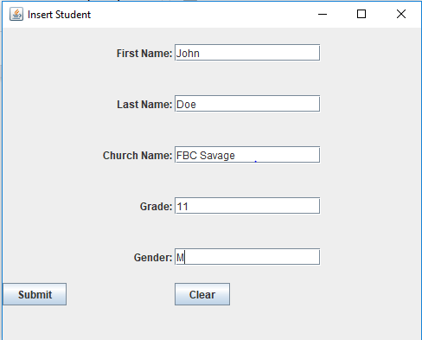

**Delete Student:**

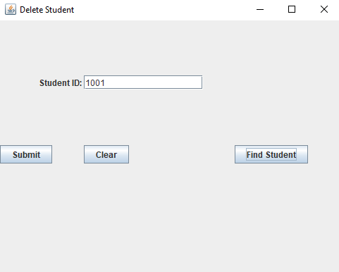

**Update Student (1):**

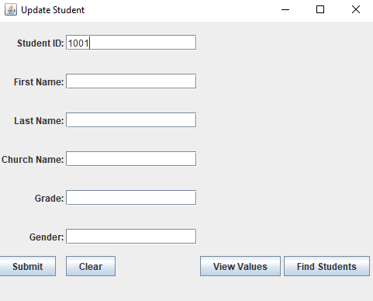

**Update Student (2):**

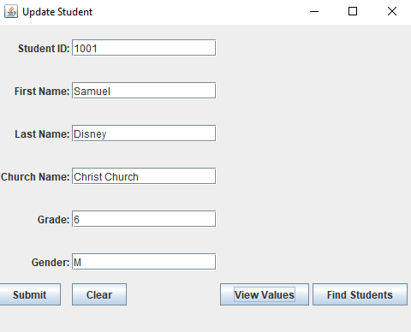

**Show Students:**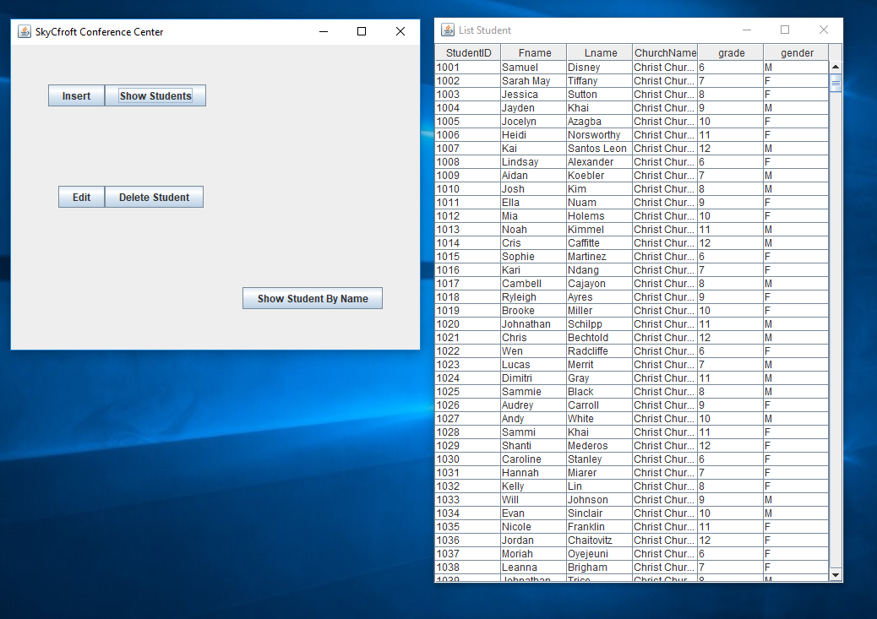

**Show Student By Name:**

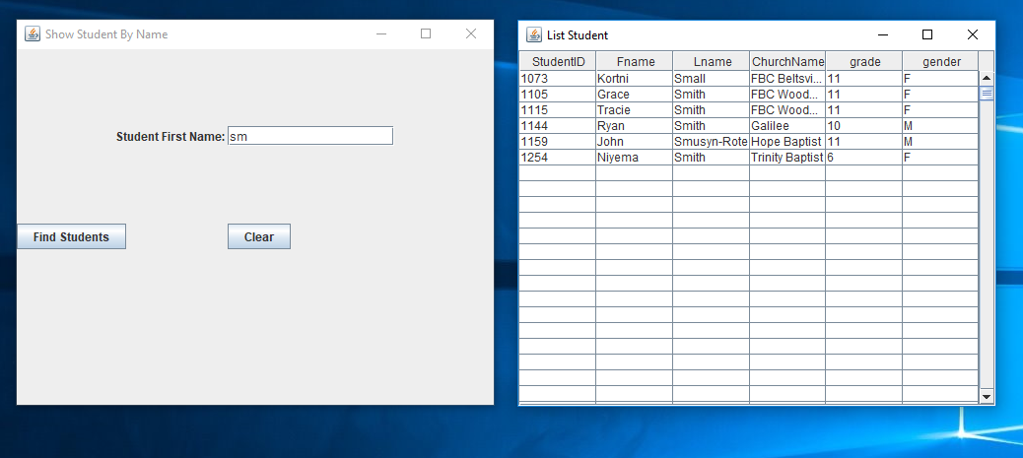

**Show Student By Gender:**

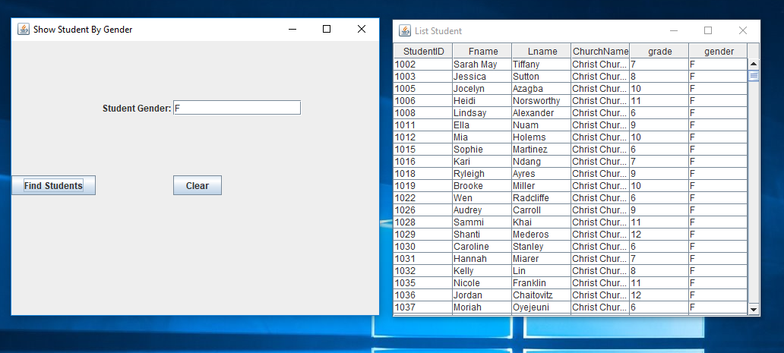

**Show Student By Church Name:**

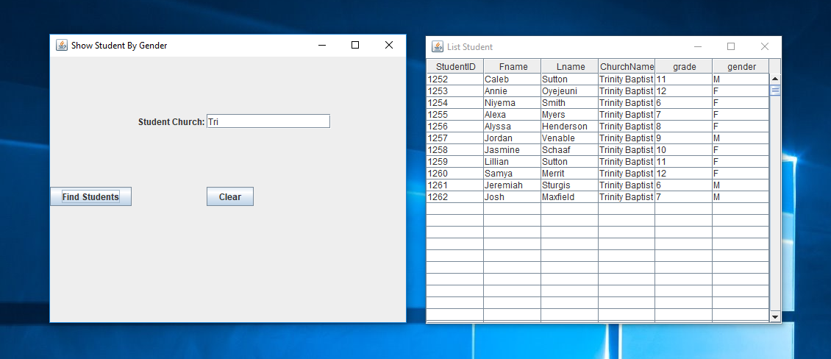

**Show Student By Circuit ID and Circuit Group:**

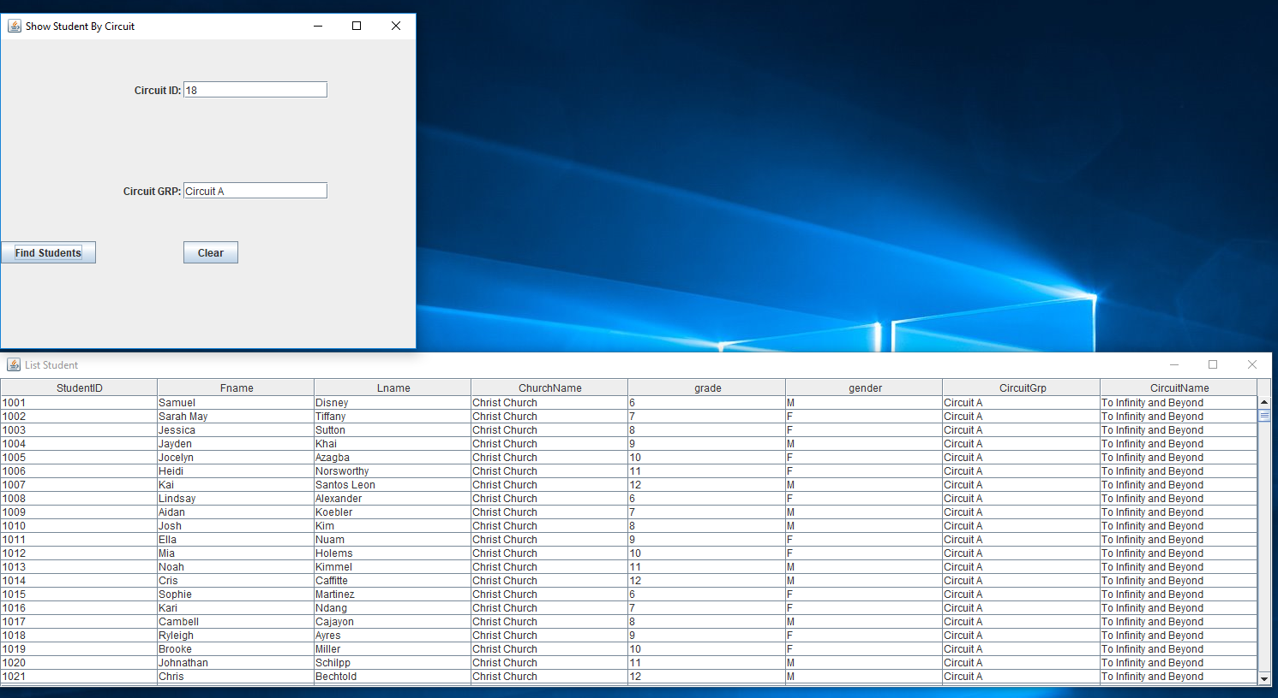

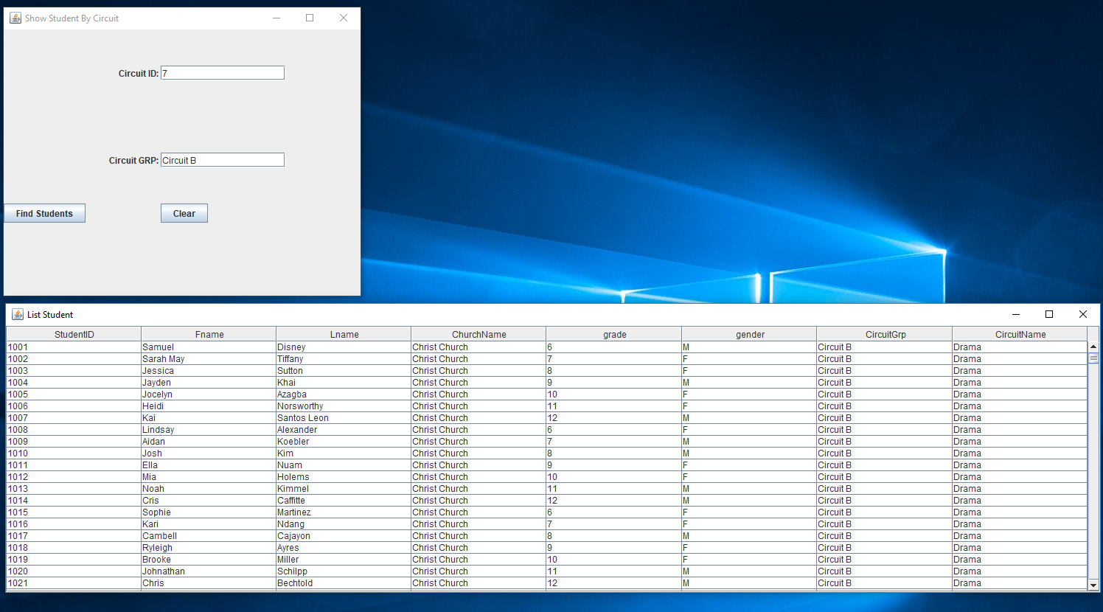

**TUTORIAL**

1. **Login:** To Login to the system follow the below steps
   1. Enter your username and password as shown in the below screenshot.
   2. Click the Submit button, this will then take you to the home page.

(See screenshot below labeled “Home Page”)



**Home Page**



1. **Insert** button: To insert/add a student click this button and complete the following steps:
   1. Enter the First Name into field provided
   2. Enter the Last Name into the field provided
   3. Enter the Church Name into the field provided
   4. Click the Submit button at the bottom left corner of the page
   5. Click the Clear button in the bottom middle of the screen to clear all fields
   6. Click the X in the top right corner to exit the Insert Student window



1. Delete Student button: To delete a student click this button on the Home Page and complete the following steps:
   1. Enter the respective student’s Student ID number
   2. Click the Find Student button to ensure the Student ID you entered is a correct match with the student you wish to delete.
   3. Click the Submit button at the bottom left corner of the page
   4. Click the Clear button in the bottom middle of the screen to clear all fields
   5. Click the X in the top right corner to exit the Insert Student window



1. **Edit/ Update Student** button: To edit/ update a student’s information click this button on the Home Page and complete the following steps:
   1. Enter the respective student’s Student ID number



* 1. Click the View Values button to ensure the Student ID you entered is a correct match with the student you wish to update.
  2. Change the students fields you wish to edit/ update with their new information



* 1. Click the Submit button at the bottom left corner of the page
  2. Click the Clear button in the bottom middle of the screen to clear all fields
  3. Click the X in the top right corner to exit the Insert Student window

1. **Show Students** button: To show a list of all students:
   1. Clicking the Show Students button on the Home Page will bring you to the screenshot page below.
   2. From the current window you can choose to:
      1. Insert a student (refer to section 2 of the Tutorial manual)
      2. Edit a student (refer to section 3 of the Tutorial manual)
      3. Delete a student (refer to section 4 of the Tutorial manual)
      4. Show students by name (refer to section 6 of the Tutorial manual)



1. **Show Students By Name** button: To show a list of all students by their name:
   1. Clicking the Show Students By Name button on the Home Page will bring you to the screenshot page below.
   2. Fill in the Student Name field with your desired characters.
   3. Click Find Students to display a list of students with names matching your criteria.



1. **Show Students By Gender** button: To show a list of all students by their gender:
   1. Clicking the Show Students By Gender button on the Home Page will bring you to the screenshot page below.
   2. Fill in the Student Gender field with either ‘F’ for female or ‘M’ for male.
   3. Click Find Students to display a list of students with who match your criteria.



1. Show Student By Church Name button: To show a list of all students by their church name:
   1. Clicking the Show Students By Church Name button on the Home Page will bring you to the screenshot page below.
   2. Fill in the Student Church field with your desired characters.
   3. Click Find Students to display a list of students who match your criteria.



1. **Show Students By Circuit** button: To show a list of all students by their circuit:
   1. Clicking the Show Students By Circuit button on the Home Page will bring you to the screenshot page below.
   2. Fill in the CircuitID field with your desired characters.
   3. Fill in the CircuitGRP field with your desired characters.
   4. Click Find Students to display a list of students who match your criteria.



